- Describe the actions you have taken to provide any information to your employees about the Zika virus.
- Answered: 12
- Skipped: 3
- None
- Webpage splash, educational in nature
- None
- not much
- monitoring the situation
- We are monitoring at an enterprise level and have shared links to information to promote awareness and to demonstrate that we are keeping an eye on developments We have not made any specific statements yet about travel or health advisories
- None
- Nothing whatsoever.
- Put together informational document. Also provided speaking points to call center agents.
- Sent email to employees with precautions issued by CDC.
- The Safety & Security staff reviewed an Article provided by InfraGard and discussed preventative measures. No information has been sent to the employees in the building.
- Talked about avoiding certain destinations

- If you have not taken actions to date, do you have plans to communicate any information to employees about the Zika virus?
- Answered: 13
- Skipped: 2
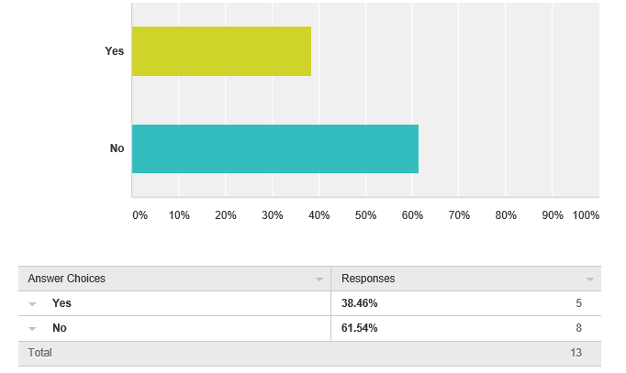
Comments:

- not considered critical
- wellness info
- if the situation worsens into the United States, than a more action will be taken
- If cases increase we may communicate more about travel advisories and personal mitigation strategies
- Company email on prevention tips
- We might advise field crews to use insect repellent, but that's about it.
- Will send update of precautions in June.
- An informational poster will be displayed at all entrances and in the break room by the end of the week.

- Have you/do you plan to institute any travel restrictions due to the potential impact of Zika?
- Answered: 13
- Skipped: 2
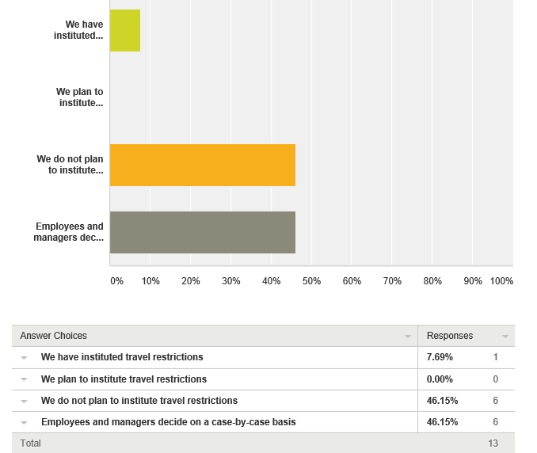
Comments:

- Mainly follow CDC &WHO recommendations then decide if travel is essential
- we have no business reasons to travel outside the US
- we are monitoring
- We really don't have people who travel outside the continental US for business purposes.
- Global travel is responsible for monitoring those countries and deciding whether to institute restrictions.
- Have you altered plans and/or advised employees to alter plans to attend conferences or meetings/events in countries with an increased Zika incidence?
- Answered: 15
- Skipped: 0
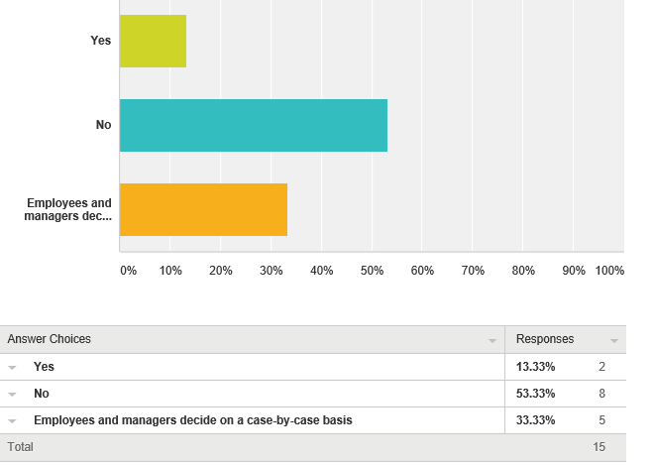
Comments:

- we have no business reasons to travel outside the US

- If possible, please provide any specific actions your organization has taken and that you are able to share…
- Answered: 6
- Skipped: 9
- none to share
- We have made some adjustments to meetings outside the US (moved them).
- we monitor all locations that have scheduled conferences and make decisions based on the threat level.
- The company doesn't see this as a threat to its people or operations. Regrettably, the field workforce is predominantly male, and the primary threat from Zika is to pregnant or likely to be pregnant women.
- The organization as a whole has not taken any action. Security Managers have taken actions to educate their staff and employee populations as they deem necessary.
- rescheduled a company trip planned for St. Croix to Florida

