AGENDA | ATTENDEES
- Call to Order President  - Welcome/Announcements President  - Program Speaker  - Wrap Up Board  - Meeting Close President | BOARD MEMBERS:  President* – Ed Simko  Treasurer* – Susan Czarnowski  Information Director – Grainne McClorey-Mitchell  Membership – Joanne Storbeck  Public Relations Director – Keith Berthiaume - Absent  Web Resources Director – Monique Hafler  Past President – Cheri Umlauf - Absent  Program Director – Liz Brainard  *Executive Committee  Absent:  President Elect – Open  Secretary* – Jill Titzer - Absent

Discussion Threads
Call to Order | Ed opened the meeting 9:03 AM  Ed reminded folks to sign in and for folks to renew membership on the National site, making sure their information is correct.
Local Sponsors | - MHA Consulting  - Fusion Risk Management  - BC in the Cloud
Meeting Host | - Host and Breakfast sponsor: Salt River Project
Welcome | - Meeting Attendance-  - Guests – 5  - Central Arizona Members - 27  - Total- 32, including speaker
Reports from your Board of Director | - President* – Ed Simko  - Announcements followed the slides  - Secretary* – Jill Titzer- Absent  - Treasurer* – Susan Czarnowski – no updates  - Information Director – Grainne McClorey-Mitchell  - Published her first newsletter. Will be sending out survey. Asked attendees to let us know of their interest in topics, speakers.  - Membership – Joanne Storbeck  - Several members still in grace. Make sure and renew on National site.  - President Elect – Open  - Program Director – Liz Brainard  - Will be sending out survey and wants feedback.  - Public Relations Director – Keith Berthiaume- Absent  - Web Resources Director – Monique Hafler  - Several new positions posted. Reminded folks that website has different information than the newsletter so encouraged all to visit it.  - Past President – Cheri Umlauf- Absent  *Executive Committee
Get Connected | - National’s site  - www.acp-international.com  - Has a lot of good information and webinars  - AZ’s site  - http://chapters.acp-international.com/centralarizona  - LinkedIn  - Arizona ACP Chapter  - Continuity Counts newsletter  - Arizona Chapter Email address  - Arizona@acp-chapters.com
Today’s Event | Speaker: Lynn James, Senior Advisory Consultant, Fusion Risk Management  Topic: Leveraging Business Process Intelligence to Increase Organizational Resiliency  The world of business continuity and disaster recovery has evolved and will continue to change. Traditional and often siloed approaches of the past will not enable today’s enterprises to achieve the level of organizational resiliency, efficiency, and agility needed. Fortunately, tools and techniques have also evolved. We now have the ability to correlate business process intelligence, gathered from BIA’s, with data from other enterprise information sources to create an information foundation that not only addresses continuity but will also increase organizational resiliency. Learn more about how effectively creating and sharing an information foundation across your business will reduce operational risk and increase overall efficiencies.  Lynn asked, “How do we contribute to all the disciplines, Business continuity (BCM), IT Disaster Recovery (DR), Emergency Management (EM)”? Gave his brief history – 1982 in oil industry – didn’t know then about BCM or IT DR. Then to Comdisco in 1986 but didn’t focus much until late 80’s and then it was on helping the business units with processes and people. He said our business is all about business processes and connectivity needed to recover and that business process excellence and BCM are converging. Information Foundation (IF) – data about the business. How will it increase efficiency within the day-to-day processes? There’s a shift from the Assess-Prepare-Response-Recovery mindset to Loss of IT, Loss of Workforce, Loss of Vendors and Loss of Suppliers.  Discussed different disciplines can be siloed. When they intersect they become bigger and work more together. This increases knowledge of BCM, ITDR, Operational Risk, EM, Incident Response and Crisis Management, which comes a lot of times from the business units. Organizational Resilience the new buzzword. ISO 22316:2017 defines and allows companies to survive and prosper. What’s next? How will companies change to support their strategic goals?  Discussed Information Foundation. Said software-enabled IF technology allows for fast and efficient tracking of component dependencies, i.e. IT applications, people, external and internal customers, records. IF can help turn around reliance from business continuity folks asking IT for information to business continuity telling IT they have already captured the information, through BIA, TIA, for them to use.  Key Takeaways:  - Review the “big data” process information you have collected with an eye on organizational resiliency  - Be an evangelist for enterprise resiliency  - Start the conversation with other enterprise domains  - Understand each other’s priorities  - Build and share your information Foundation to increase resilience  - Everything starts and ends with the Business Units.  Contact info: Contact Grainne Mitchell. M: (480) 353-1402 linkedin.com/in/grainnemcclorey  Questions/Comments:  Q – Are members using resiliency vs business continuity management in their companies?  A – One member said she’s pushing it at hers.  Q- What are we seeing to how companies react to cyber threats?  A – Falls in to the security group. Mitigation efforts should be more robust. In BCM it’s put it in a plan vs. Daily activity, specialized equipment, i.e. is there duplicate equipment in the recovery site/alternative facility? Cyber threats are a part of this type of loss. Ask business units how would a cyber-incident impact you?  Q – Will changes to ISO 22301 change ISO 22316?  A – He thinks it will eventually since they go together.  Q – Where does this connect with Enterprise Risk Management (ERM)?  A – Another circle that sometimes is a big one that manages all of the disciplines. Sets the level of tolerance or risk companies are willing to accept.  Q – Where do you think the moving targets will be in a year for ERM, BCM, and Organizational Resilience?  A – It will be than a year and it depends on the threat of the day. Today it’s cyber. It’s driven by the “catastrophe de jour”. Boeing does it by having open and constant communication. The CSO owns the BCM program and now shares responsibility with other disciplines that intersect. All have to work together to get things done.  Q – Vendors are reluctant to share BC plans. How can you define their recovery if they don’t?  A – They are apt to provide high level results at the time of contract renewal. Be cognizant of what’s going to be in contract up front. Try to get results of last DR test.
Next Meeting | Date: March 7, 2019  Location: Boeing, 5000 E. McDowell Rd. Mesa AZ  Parking is at corner of McDowell and Higley. Must walk.  Speaker: Round Table Discussion of Threat Notification and Employee Notification Tools. Boeing GSOC Tour. (Global Security Op Center)  Topic:  Tour of Boeing Security Operations Center. Brief roundtable discussion on threat notification and rapid notification tools (i.e. NC4, etc.)
Program Outlook | 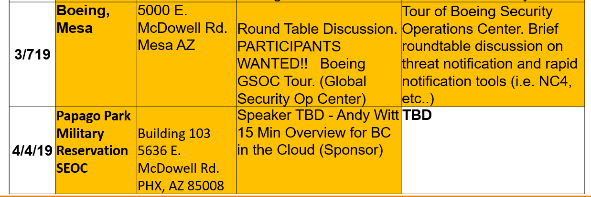
Events | - ACP 2019 One Day Conference -- Sunday, February 17, 2019; Planet Hollywood Resort & Casino, Las Vegas NV; in conjunction with DRI2019. Details coming soon.  - DRI2019 The Professional's Conference -- February 17-20, 2019; Planet Hollywood Resort & Casino, Las Vegas NV; Information and registration here.  - DRJ Spring 2019: Managing Risk in an Uncertain World -- March 24-27, Disney's Coronado Springs Resort, Orlando, FL. Information and registration here.  - 2019 Continuity Insights Management Conference -- April 15-17, 2019, Hilton Riverside New Orleans, LA. Information and registration here.  - Gartner Security & Risk Management Summit 2019 -- June 17 - 20, 2019; National Harbor, MD. More information here.
Wrap Up | - 50/50 Winner: $11 to Marc Sakowitz  - Achievements – Brian Knutson with University of Phoenix received, MCBCI,CHCP and SA – SAFe 4 Agilist.  - Discussion topics/ Member concerns? Boeing has strict check-in procedures so attendees are encouraged to get there early. You will need documented ID, possibly a Passport if your ID is not federal/state approved and know your country of origin.  - Early Warning Systems has a Director/Manager-level Business Continuity position open. Harlin to send info to Monique to post on website.
 | Meeting adjourned at 10:54 am

