TOASTMASTERS INTERNATIONAL
The world needs leaders. Leaders head families, coach teams, run businesses and mentor others. These leaders must not only accomplish, they must communicate. By regularly giving speeches, gaining feedback, leading teams and guiding others to achieve their goals in a supportive atmosphere, leaders emerge from the Toastmasters program. Every Toastmasters journey begins with a single speech. During their journey, they learn to tell their stories. They listen and answer. They plan and lead. They give feedback—and accept it. Through our community of learners, they find their path to leadership.

Toastmasters International Mission
We empower individuals to become more effective communicators and leaders.
Club Mission
We provide a supportive and positive learning experience in which members are empowered to develop communication and leadership skills, resulting in greater self-confidence and personal growth.

Toastmasters International Values
- Integrity
- Respect
- Service
- Excellence

Toastmasters International Envisioned Future
To be the first-choice provider of dynamic, high-value, experiential communication and leadership skills development.

Toastmasters began as a series of speaking clubs organized at the YMCA in Bloomington, Illinois.
As director of education at the YMCA, Ralph C. Smedley saw a need for the men in the community to learn how to speak, conduct meetings, plan programs and work on committees.

Smedley decided to organize a club where they could learn these skills in a social environment, and the men responded well to the concept. He named the group the Toastmasters Club; "toastmaster" was a popular term that referred to a person who gave toasts at banquets and other occasions.

The first unofficial Toastmasters meeting was held on March 24, 1905.

The first official meeting of Club No. 1 of Toastmasters International was held at the new YMCA building in Santa Ana, CA on October 22, 1924.

Smedley secured copyrights on his "Manual of Instructions" and "Ten Lessons in Public Speaking," and on October 25, 1928, he trademarked the name "Toastmasters Club."

By 1930, nearly 30 Toastmasters clubs had formed including a club in British Columbia, Canada. Two years later, in 1932, Toastmasters International was incorporated as a California non-profit organization. Ralph C. Smedley died in 1965.

In 1970, Toastmasters International admitted its first female member, Helen Blanchard, under the name Homer Blanchard. In 1973, Toastmasters began officially admitting women, and in 1985, Helen became Toastmasters' first female international president.

Today
Toastmasters International is a world leader in communication and leadership development. Our membership is more than 332,000 memberships. Members improve their speaking and leadership skills by attending one of the 15,400 clubs in 135 countries that make up our global network of meeting locations.

Where To Start
http://www.toastmasters.org/
http://www.toastmasters.org/Find-a-Club
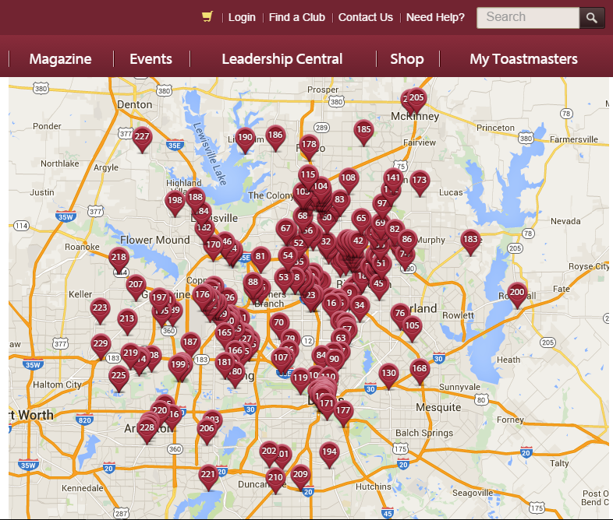
http://dallastoastmasters.com/

