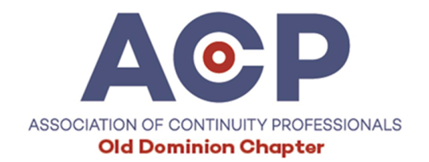

February 25, 2020 Meeting

BC Software Discussion

Review of various alternatives:
- IBM Managed Services, Continuity Logic and Resiliency Orchestration – Clif Hairfield
  - See PDF
- Plan-A-ware – Clarence Elliott
https://www.attainium.net/products-services/plan-a-ware
- Recovery Planner/RPX – Clarence/Frankie Blevins https://www.recoveryplanner.com/bcm-erm-software-solutions#rpx-software
- State template: Word and Excel – Connie Riffe
- LDRPS transition to SharePoint, Archer, etc. - discussion
- Assurance, Fairchild, Fusion –- check web sites
- Gartner reviews/Magic Quadrant - check web site https://www.gartner.com/reviews/market/business-continuity-management-program-solutions

Missed a meeting? You can find presentations from past meetings at:
https://chapters.acp-international.com/olddominion-events

