November 2016 Meeting Notice

MEETING DATE: Tuesday, November 15th (Note that the meeting is earlier in the month than usual.)

TIME: Registration at 11:30; meeting from 12:00 to 2:00

LOCATION: The Grapevine Restaurant
11055 Three Chopt Road (See map on next page)

SPEAKER: Clarence Elliott, President of the ACP Old Dominion Chapter, will be leading the meeting and discussion

PROGRAM: 1. ACP ODC Elections (Only members in good standing can vote)

2. Roundtable Discussion: “What’s in Your Plan?” – What is different, what works, needs improvement, etc. Share information and get suggestions and ideas from others.

MEETING FEE: Members: $10.00 Non-members: $15.00

RSVP: Please RSVP via replying to the email that accompanied this invitation or directly to
ACP_ODC@Comcast.net no later than Thursday November 10th.

Missed a meeting? You can find presentations from past meetings at:
http://olddominion.acp-international.com/index.php/events

WE HOPE TO SEE YOU THERE!

The Grapevine Restaurant
11055 Three Chopt Road

Parking lot can be entered off of Cox Road
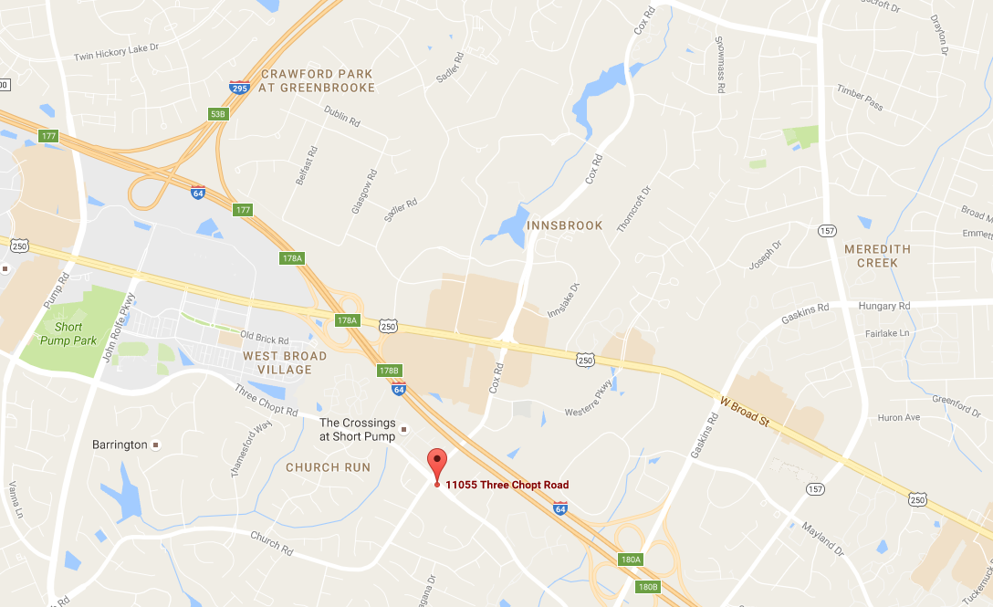
Parking lot entrance

